**Practical-2**

**Aim: Console applications: Basic Concepts.**

**1.Write a program to get integer, double, character and string values from the user and display it on the screen.**

**Program:**

using System;

namespace Practical2

{

class Program

{

static void Main(string[] args)

{

Console.WriteLine("Enter Value");

int a = Convert.ToInt32(Console.ReadLine());

Console.WriteLine("You entered Number is : " + a);

Console.WriteLine("Enter Name:");

string name = Console.ReadLine();

Console.WriteLine("Your name is: " + name);

Console.WriteLine("Please Entered Char:");

char b = Convert.ToChar(Console.ReadLine());

Console.WriteLine("You entered char is :" + b);

Console.WriteLine("Entered Double");

Double c = Convert.ToDouble(Console.ReadLine());

Console.WriteLine("You Entered Doubble is :" + c);

Console.ReadKey();

}

}

}

**Output:**

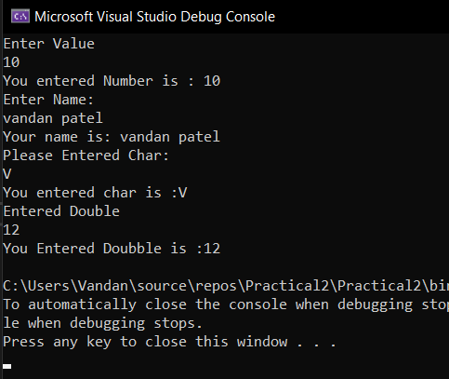

**2. Write a program to check whether the entered value is numeric or not. [Note: use try and catch.]**

**Program:**

using System;

using System.Collections.Generic;

using System.Linq;

using System.Text;

using System.Threading.Tasks;

namespace PR2

{

class Exp2

{

static void Main(string[] args)

{

double d;

Console.WriteLine("Vandan Patel\n");

try

{

Console.WriteLine("Enter any Value=");

d = Convert.ToDouble(Console.ReadLine());

Console.WriteLine("Entered number is Numeric");

}

catch

{

Console.WriteLine("Entered number is not Numeric");

}

Console.ReadKey();

}

}

}

**Output:**

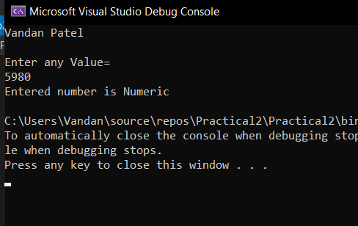

**3. Write a program to accept a number from the user and throw an exception if the number is not an even number.**

**Program:**

using System;

namespace Practical2_3

{

class Program

{

static void Main(string[] args)

{

int answer;

Console.WriteLine("Enter any number");

int a = Convert.ToInt32(Console.ReadLine());

answer = a % 2;

if ( answer== 0)

{

Console.WriteLine("your number is even number");

}

else

{

Console.WriteLine("not even number");

}

}

}

}

**Output:**

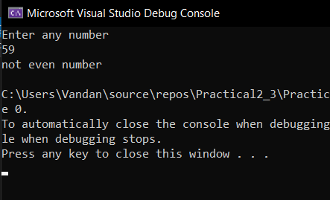

**4. Write a program to find whether the given year is leap year or not. (Leap year is evenly divisible by 4, but if it is evenly divisible by 100 then it is not a leap year, but if it is evenly divisible by 400, then it is a leap year)**

**Program:**

using System;

namespace Practical2_4

{

class Program

{

static void Main(string[] args)

{

Console.WriteLine("Enter Year");

int year = Convert.ToInt32(Console.ReadLine());

if(((year % 4 == 0) && ((year % 400 == 0) || (year % 100 != 0))))

{

Console.WriteLine("Leep Year");

}

else

{

Console.WriteLine("Not leep year");

}

}

}

}

**Output:**

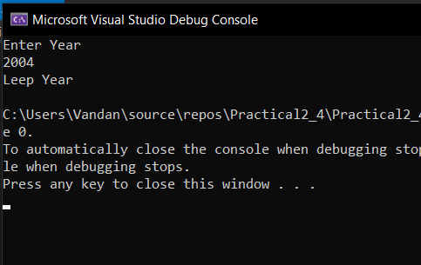

**5. Write a program to check whether the given number is perfect or not. A number is perfect if the sum of its divisor is same as multiplication of all digits. (For example: 6 which can be divided by 1, 2 and 3 so 1+2+3=6)**

**Program:**

using System;

using System.Collections.Generic;

using System.Linq;

using System.Text;

using System.Threading.Tasks;

namespace Pr2_5

{

class Class4

{

static void Main(string[] args)

{

int i, n;

int sum = 0;

Console.WriteLine("Vandan Patel\n");

Console.WriteLine("Enter the number:");

n = Convert.ToInt32(Console.ReadLine());

for (i = 1; i < n; i++)

{

if (n % i == 0)

{

sum = sum + i;

}

}

if (sum == n)

Console.WriteLine("The Number is Perfect");

else

{

Console.WriteLine("The Number is Not Perfect");

}

Console.ReadKey();

}

}

}

**Output:**

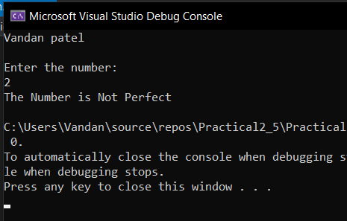

**6. Write a program to check whether the given number is lucky or not. (A number is lucky if the number is itself a prime and the sum of digit of a number is also prime) Program:**

using System;

using System.Collections.Generic;

using System.Linq;

using System.Text;

using System.Threading.Tasks;

namespace Praactical2_6

{

class Class5

{

static void Main(string[] args)

{

int i, n, mod, flag = 1, sum = 0, temp;

Console.WriteLine("Vandan Patel\n");

Console.WriteLine("Enter any number to check whether its lucky or not:\n");

n = Convert.ToInt32(Console.ReadLine());

temp = sum;

for (i = 2; i < n; i++)

{

if (n % i == 0)

{

flag = 0;

Console.WriteLine("\n{0} is not prime number so it can not be even luck number also", n);

break;

}

}

if (flag == 1)

{

while (n > 0)

{

mod = n % 10;

sum += mod;

n /= 10;

}

for (i = 2; i < sum; i++)

{

if (sum % i == 0)

{

flag = 0;

Console.WriteLine("The sum {0} is divided by the value { 1}", sum, i);

break;

}

}

if (flag == 1)

Console.WriteLine(" is a Lucky number", temp);

else

Console.WriteLine(" is not a Lucky number",temp);

}

}

}

}

**Output:**

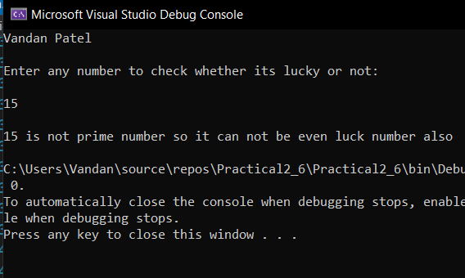

**7. Write a program to generate Floyds Triangle.**

**Program:**

using System;

using System.Collections.Generic;

using System.Linq;

using System.Text;

using System.Threading.Tasks;

namespace Practical2_6

{

class Ep7

{

static void Main(string[] args)

{

int n, i, j, count = 1;

Console.WriteLine("Vandan Patel\n");

Console.WriteLine("Enter The Number:");

n = Convert.ToInt32(Console.ReadLine());

for (i = 1; i <= n; i++)

{

for (j = 1; j <= i; j++)

{

Console.Write(count + "");

count++;

}

Console.WriteLine();

}

}

}

}

**Output:**

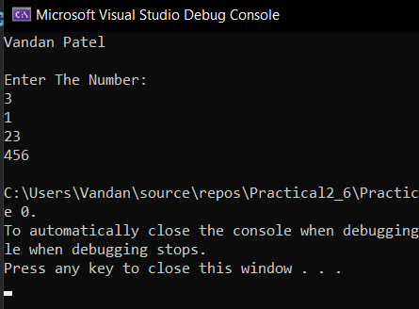

**8. Write a program to replace a substring of given length with new substring. (Input: starting index and length of substring)**

**Program:**

using System;

using System.Collections.Generic;

using System.Linq;

using System.Text;

using System.Threading.Tasks;

namespace Practical2_6

{

class Ep8

{

static void Main(string[] args)

{

Console.WriteLine("Vandan Patel\n");

Console.WriteLine("Enter any String:");

string s = Console.ReadLine();

Console.Write("Enter the word which you want to replace: ");

string a = Console.ReadLine();

Console.Write("Enter the new word:");

string sub = Console.ReadLine();

string New = s.Replace(a, sub);

Console.Write("New String is: " + New + "\n\n");

}

}

}

**Output:**

